

**ISOLATION AREA MANAGEMENT SYSTEM**

**Software Design Document**

– Hanoi, January 2022 –

**Table of Contents**

I. Overview 3

1. Code Packages 3

2. Database Schema 3

II. Code Designs 4

1. <Feature/Function Name1> 4

a. Class Diagram 4

b. Class Specifications 4

c. Sequence Diagram(s) 4

d. Database queries 5

2. <Feature/Function Name2> 5

III. Database Tables 5

1. <Table name 1> 5

2. <Table name 2…> 5

# I. Overview

## 1. Code Packages/Namespaces

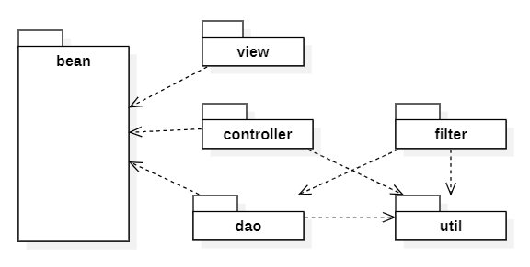

***Package descriptions & package class naming conventions***

| **No** | **Package** | **Description** |
| --- | --- | --- |
|  |  |  |
|  |  |  |

## 

# II. Code Designs

## 1. <Feature/Function Name1>

*[Provide the detailed design for the function <Feature/Function Name1>. It include Class Diagram, Class Specifications, and Sequence Diagram(s)]*

### a. Class Diagram

*[This part presents the class diagram for the relevant feature]*

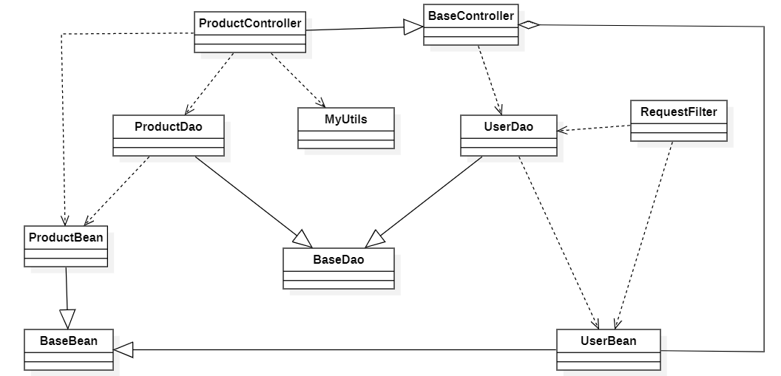

### b. Class Specifications

*[Provide the description for each class and the methods in each class, following the table format as below]*

#### XYZ Class

*[Provide the detailed description for the class methods]*

| **No** | **Method** | **Description** |
| --- | --- | --- |
| *01* | *<method name>* | *<Description of the method, including the inputs, outputs & internal method processing>* |
|  |  |  |

#### ABC Class

***Class Methods***

*[Provide the detailed description for the class methods]*

| **No** | **Method** | **Description** |
| --- | --- | --- |
| *01* | *<method name>* | *<Description of the method, including the inputs, outputs & internal method processing>* |
|  |  |  |

### c. Sequence Diagram(s)

*[Provide the sequence diagram(s) for the feature, see the sample below]*

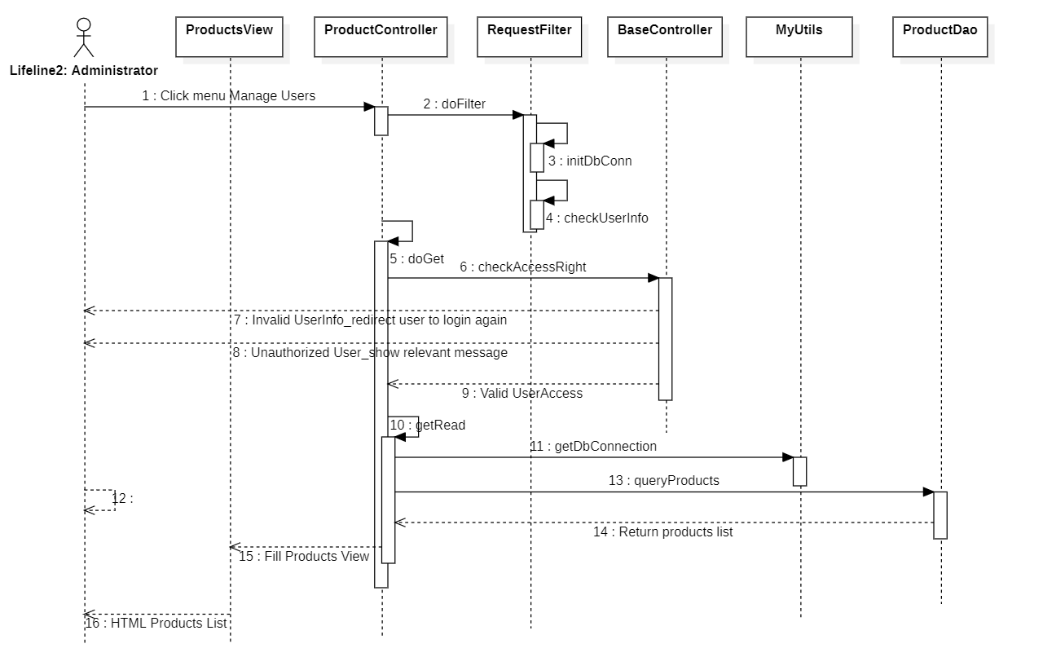

### d. Database queries

*[Provide the detailed SQL (select, insert, update...) which are used in implementing the function/screen]*

## 2. <Feature/Function Name2>

…

# III. Database Design

## 1. Database Schema

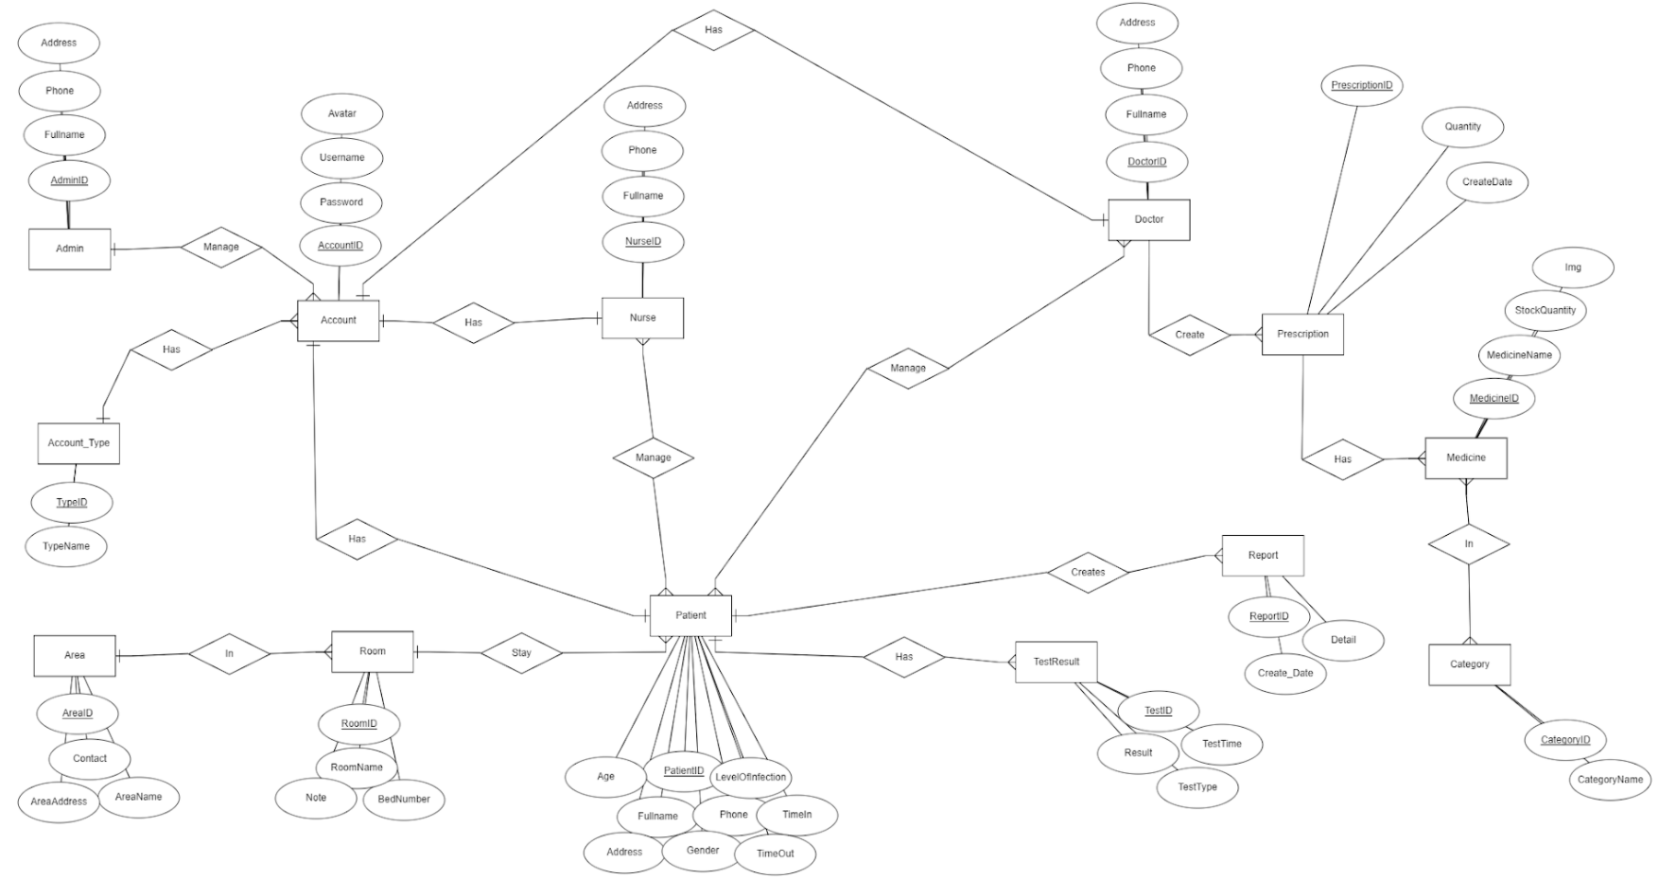

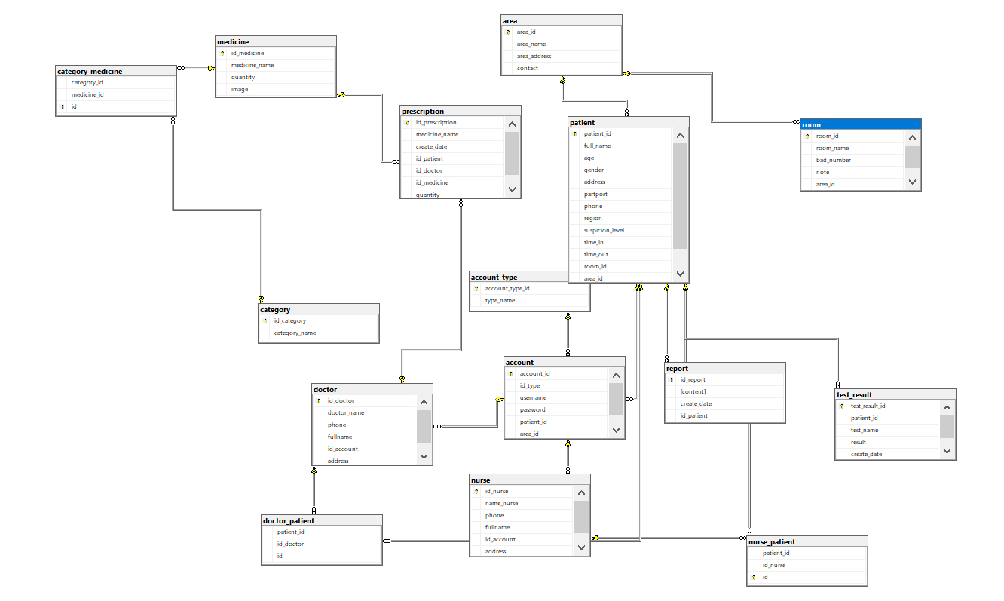

## 2. Table Description

| **No** | **Table** | **Description** |
| --- | --- | --- |
| 01 | account | - Primary keys: account_id  - Foreign keys: account_type_id |
| 02 | account_type | - Primary keys: account_type_id  - Foreign keys: |
| 03 | doctor | - Primary keys: id_doctor  - Foreign keys: account_id |
| 04 | nurse | - Primary keys: id_nurse  - Foreign keys: account_id |
| 05 | patient | - Primary keys: id_patient  - Foreign keys: account_id |
| 06 | prescription | - Primary keys: id_prescription  - Foreign keys: id_doctor, id_patient, id_medicine |
| 07 | medicine | - Primary keys: id_medicine  - Foreign keys: |
| 08 | category | - Primary keys: id_category  - Foreign keys: |
| 09 | room | - Primary keys: room_id  - Foreign keys: area_id |
| 10 | area | - Primary keys: area_id  - Foreign keys: |
| 11 | test_result | - Primary keys: test_result_id  - Foreign keys: id_patient |
| 12 | report | - Primary keys: id_report  - Foreign keys: id_patient |
| .. |  | - Primary keys:  - Foreign keys: |